  AIML VITYARTHI PROJECT | NAME- GORANSHI AGARWAL  REG NO.- 25BAI11505

- INTRODUCTION TO THE PROBLEM
This project implements a solution to the 8-puzzle problem using the A* search algorithm, a fundamental concept in Artificial Intelligence.
The 8-puzzle consists of a 3×3 grid with tiles from 1 to 8 and one blank space (represented by 0). The objective is to rearrange the tiles from an initial state to a goal state using the minimum number of moves (optimal solution).
The program takes input for the initial state, checks whether the puzzle is solvable, and then applies the A* algorithm with the Manhattan heuristic to find the optimal solution. It outputs the number of steps required along with the step-by-step transformation from the initial state to the goal state.

- PROBLEM STATEMENT
The 8-puzzle consists of: A 3×3 grid
- 8 numbered tiles (1 to 8)
- 1 blank space (represented by 0)
Objective:
To rearrange the tiles from an initial state to a goal state in the minimum number of moves
Rules:
- Only the 0 (blank space) can be moved
- Moves allowed: Up, Down, Left, Right
- Each move has equal cost
- Not all input puzzles are solvable

- SIGNIFICANCE
This problem helps us to gain knowledge about various AI algorithms such as:
- Introduce to state space search techniques
- understanding heuristic-based algorithms
- Demonstrates optimal pathfinding
- Forms a base for real-world applications such as:
- Navigation systems
- Game AI
- Robotics

- CONCEPTS USED:
- A* search Algorithm
The A* algorithm is an informed search algorithm used in Artificial Intelligence to find the shortest and most optimal path from a starting point to a goal.
A* works by choosing the best node (state) based on a cost function:
F(n) = g(n) + h(n)
Where:
- g(n) = Actual cost from start to current node
- h(n) = Estimated cost from current node to goal (heuristic)
- f(n) = Total estimated cost
Advantages:
- Always finds the shortest path
- Gives best possible result if heuristic is correct
- Guarantees a solution if it exists
- Uses heuristic and avoids unnecessary paths
- Uses Intelligent Decision Making
- Heuristic Function
The Manhattan Distance heuristic is used:
- It calculates the distance of each tile from its correct position
- Total distance = sum of all tile distances
- This heuristic improves efficiency and guarantees optimal results.

- PYTHON CODE
- from queue import PriorityQueue

- goalstate = [[1,2,3],
- [4,5,6],
- [7,8,0]]

- moves = [(-1,0),(1,0),(0,-1),(0,1)]

- def findblank(state):
- for i in range(3):
- for j in range(3):
- if state[i][j] == 0:
- return i, j

- def heuristic(state):
- distance = 0
- for i in range(3):
- for j in range(3):
- value = state[i][j]
- if value != 0:
- x = (value - 1) // 3
- y = (value - 1) % 3
- distance += abs(i - x) + abs(j - y)
- return distance

- # Convert to tuple
- def totuple(state):
- return tuple(tuple(row) for row in state)

- def print_stack(state):
- for row in state:
- print(row)
- print()

- def solvable(state):
- flat = [num for row in state for num in row if num != 0]
- inversions = 0
- for i in range(len(flat)):
- for j in range(i+1, len(flat)):
- if flat[i] > flat[j]:
- inversions += 1
- return inversions % 2 == 0

- # A* Solver
- def solvepuzzle(start):
- pq = PriorityQueue()
- pq.put((0, start, 0, [])) # (f, state, g, path)

- visited = set()

- while not pq.empty():
- f, state, g, path = pq.get()

- if state == goalstate:
- print("Solution Found!")
- print("Steps:", g)
- print("\nPath:\n")
- for step in path + [state]:
- print_stack(step)
- return

- visited.add(totuple(state))

- x, y = findblank(state)

- for dx, dy in moves:
- nx, ny = x + dx, y + dy

- if 0 <= nx < 3 and 0 <= ny < 3:
- new_state = [row[:] for row in state]
- new_state[x][y], new_state[nx][ny] = new_state[nx][ny], new_state[x][y]

- if totuple(new_state) not in visited:
- h = heuristic(new_state)
- pq.put((g + 1 + h, new_state, g + 1, path + [state]))

- print("No solution found")

- # 🔹 TAKE INPUT FROM USER
- print("Enter the 8-puzzle (use 0 for blank):")

- start_state = []
- for i in range(3):
- row = list(map(int, input(f"Enter row {i+1} (space separated): ").split()))
- start_state.append(row)

- print("\nInitial State:")
- print_stack(start_state)

- # Check solvability
- if solvable(start_state):
- solvepuzzle(start_state)
- else:
- print("This puzzle is NOT SOLVABLE")

6. WORKING
- Take Initial Input from User
- The program starts by taking a 3×3 matrix input
- User enters numbers from 0 to 8
- Where 0 represents the blank space
- 0 can only be moved

- Check Solvability using Inversion Count
- Before solving, the program checks if the puzzle can be solved
- It counts inversions (wrong order pairs)
Rules
Even inversions are Solvable
Odd inversions are Not solvable

- Initialize Priority Queue
- A priority queue is created to store states
- States are arranged from lowest to highest cost
- This ensures the algorithm always picks the best state also called optimal solution

- Generate Possible Moves
- From the current state, all valid moves are generated:
  - Up
  - Down
  - Left
  - Right

- Calculate Cost Function for Each State
The cost is calculated using:
$$f(n)=g(n)+h(n)$$
- g(n) = number of moves so far
- h(n) = heuristic cost

- Select State with Lowest Cost
- From the priority queue, the state with lowest f(n) is selected
- This is the most suitable state

- . Repeat Until Goal State is Reached
- Steps 4–6 are repeated:
  - Generate new states
  - Calculate cost
  - Select the best state out of them
- Loop continues until:
- Goal state is found
OR
- No more states available

- Display Solution Path
- Once the goal is reached:
- Print the number of steps
- Show step-by-step states as solution

7. SAMPLE INPUT

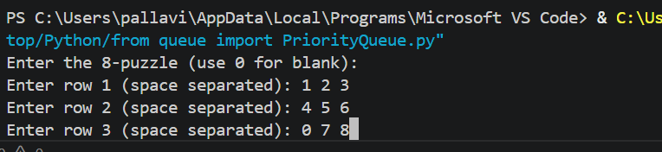
The program requires the user to provide the initial configuration of the 8-puzzle.
Input should be in format of
- A 3×3 matrix
- Values range from 0 to 8
- Each number appears exactly once
- 0 represents the blank space
Rules
- User enters values row by row
- Spaces separate each numbers

8. SAMPLE OUTPUT
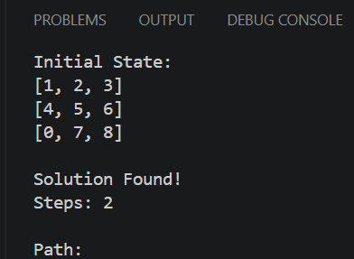

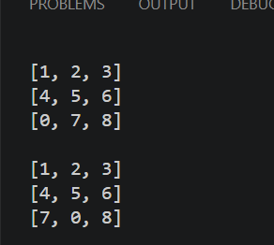

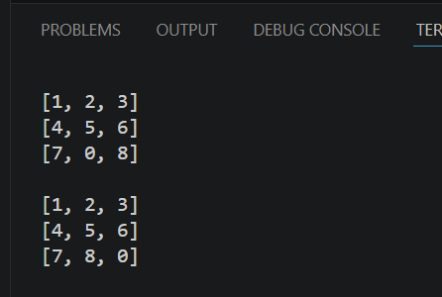
.
For output
The first code will check whether the problem is solvable or not via the solvability check.
- If not, the result will be displayed as “ This problem is NOT SOLVABLE”
- If yes, then it will solve the problem step-by-step with all possible methods and find the optimal solution and path cost

9. FUTURE ENHANCEMENT:
1. Graphical User Interface (GUI)
- Convert CLI program into a visual interactive interface
- Use tools like:
    - Tkinter (Python)
- Show puzzle as clickable tiles
- Makes the project more user-friendly and attractive

2. Animation of Solution Steps
- Display tile movements step-by-step visually
- Animate transitions between states
- It Helps in better understanding and presentation
3. Extend to Larger Problems
- Expand project to: 15-puzzle (4×4 grid)

10. REFERENCES:

- GeeksforGeeks - A* Search Algorithm
- Wikipedia - A* Search Algorithm
- Khan Academy (Youtube)

